

**Name:** Fatima Malik

**Sap ID:** 40089

**Semester:** BSCS-6

**Course:** Computer Networks

**Lab 3**

**Task 1:**

**What is Ethernet cable? What type Ethernet cable is most commonly used in LAN network?**

Ethernet cables are used to link devices in a LAN network, with **Cat 5e** and **Cat 6** being the most common types. **Cat 5e** supports speeds up to 1 Gbps over 100 meters, while **Cat 6** supports up to 10 Gbps over shorter distances. Cat 6 is often preferred for higher performance.

**Task 2:**

**What is a LAN (local area network)? When and why to use LAN cable to send files from one computer to another?**

A LAN (local area network) is a network that connects devices within a limited area, like a home or office. Using a LAN cable to send files between computers provides a stable, high-speed connection with minimal interference, ensuring faster and more reliable transfers compared to wireless options.

**Task 3:**

**How Does LAN Work? What is meant by 127.0.0.1 and localhost?**

A LAN connects devices within a limited area for resource sharing and communication. **127.0.0.1** is the loopback IP address for the local machine, while **localhost** is the hostname that resolves to the same address. Both are used for internal testing and development.

**Task 4:**

**How two computers can share files through disk sharing.**

Two computers can share files through disk sharing by setting up one computer to share a specific folder or drive over the network. The other computer can then access this shared folder using network browsing or mapping it as a network drive, allowing files to be copied or edited remotely.

**Step 1:**

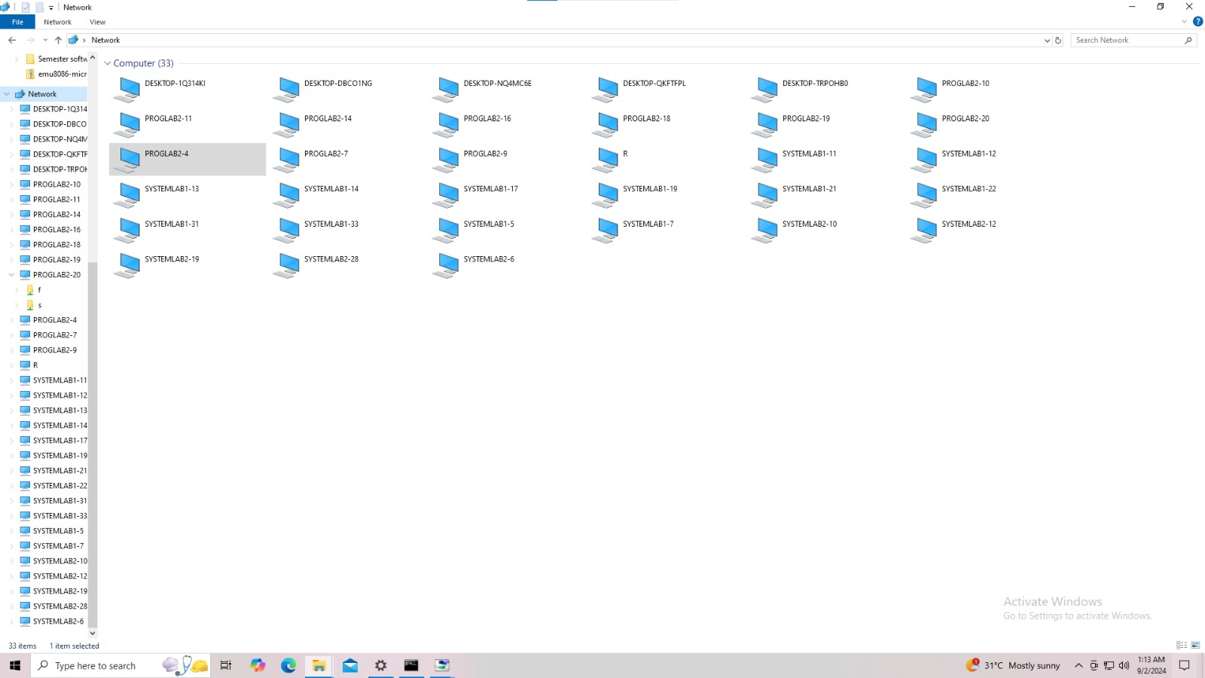

**Step 2:**

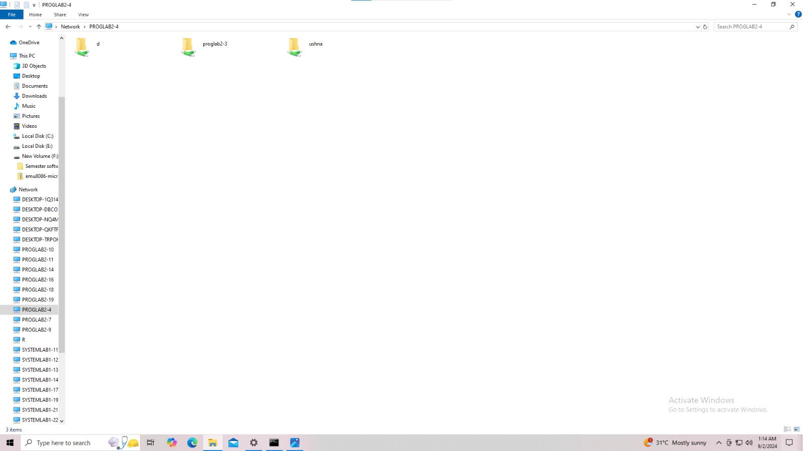

**Step 3:**

